**CS PROJECT**



**Made by:** Aarav Menon (Roll no 1)

**Class:** XII-A

**Board Roll no:**

**Contents:**

1. CERTIFICATE
2. ACKNOWLEDDGEMENT
3. INTRODUCTION
4. CODE
5. OUTPUT
6. BIBLIOGRAPHY

**CERTIFICATE**

**This is to certify that Aarav Menon of class XII – A has prepared a report on the project titled “Anime-hub”. The report is the result of his efforts and endeavours. The report is found worthy of acceptance as final project report for the subject Computer Science of class XII. They have prepared the report under my guidance, for the academic year 2020 – 2021.**

**Pooja Dhingra**

**(HOD Computer Science)**

**ACKNOWLEDGEMENT**

**We would like to express our greatest gratitude to the people who have helped and supported us throughout the project. We are grateful to our teacher for her continuous support for the project from initial advice in the early stages of conceptual inceptions and throughout the ongoing advice and encouragement.**

**INTRODUCTION**

**“Anime-hub” is a program which focuses mainly on anime management. This program tells us many information which are required for those who watch anime. The project gives us various outputs from MySql tables:**

* **Top Grossing Anime**
* **Best 2020 Anime**
* **Top Ongoing Anime**
* **Upcoming Anime**
* **Random Anime**
* **Top 10 Anime Scenes**
* **Official My Anime List sites**

**The project is made up of mainly 4 libraries PyQt, random, mysql.connector and sys.**

**This program contains a total of 8 python IDLE files and 5 images and it has also used PyQt designer for some of the GUI windows.**

**CODES**

**File 1 - ca1**

**import sys**

**import platform**

**from PyQt5 import QtCore, QtGui, QtWidgets**

**from ca2 import Ui_MainWindow_1**

**class Ui_MainWindow(object):**

**def pushButton_function(self):**

**self.window = QtWidgets.QMainWindow()**

**self.ui = Ui_MainWindow_1()**

**self.ui.setupUi(self.window)**

**MainWindow.hide()**

**self.window.show()**

**def setupUi(self, MainWindow):**

**MainWindow.setObjectName("MainWindow")**

**MainWindow.resize(800, 600)**

**self.centralwidget = QtWidgets.QWidget(MainWindow)**

**self.centralwidget.setObjectName("centralwidget")**

**self.label = QtWidgets.QLabel(self.centralwidget)**

**self.label.setGeometry(QtCore.QRect(0, 0, 801, 281))**

**self.label.setText("")**

**self.label.setPixmap(QtGui.QPixmap("Anime hub logo.png"))**

**self.label.setScaledContents(True)**

**self.label.setObjectName("label")**

**self.label_2 = QtWidgets.QLabel(self.centralwidget)**

**self.label_2.setGeometry(QtCore.QRect(0, 280, 401, 301))**

**self.label_2.setText("")**

**self.label_2.setPixmap(QtGui.QPixmap("luffy.jpg"))**

**self.label_2.setScaledContents(True)**

**self.label_2.setObjectName("label_2")**

**self.label_3 = QtWidgets.QLabel(self.centralwidget)**

**self.label_3.setGeometry(QtCore.QRect(400, 280, 401, 301))**

**self.label_3.setText("")**

**self.label_3.setPixmap(QtGui.QPixmap("rock lee.jpg"))**

**self.label_3.setScaledContents(True)**

**self.label_3.setObjectName("label_3")**

**self.pushButton = QtWidgets.QPushButton(self.centralwidget)**

**self.pushButton.setGeometry(QtCore.QRect(340, 270, 111, 23))**

**font = QtGui.QFont()**

**font.setFamily("System")**

**font.setBold(True)**

**font.setWeight(75)**

**self.pushButton.setFont(font)**

**self.pushButton.setObjectName("pushButton")**

**MainWindow.setCentralWidget(self.centralwidget)**

**self.menubar = QtWidgets.QMenuBar(MainWindow)**

**self.menubar.setGeometry(QtCore.QRect(0, 0, 800, 21))**

**self.menubar.setObjectName("menubar")**

**MainWindow.setMenuBar(self.menubar)**

**self.statusbar = QtWidgets.QStatusBar(MainWindow)**

**self.statusbar.setObjectName("statusbar")**

**MainWindow.setStatusBar(self.statusbar)**

**self.pushButton.clicked.connect(self.pushButton_function)**

**self.retranslateUi(MainWindow)**

**QtCore.QMetaObject.connectSlotsByName(MainWindow)**

**def retranslateUi(self, MainWindow):**

**_translate = QtCore.QCoreApplication.translate**

**MainWindow.setWindowTitle(_translate("MainWindow", "MainWindow"))**

**self.pushButton.setText(_translate("MainWindow", "Press to Open"))**

**if __name__ == "__main__":**

**import sys**

**app = QtWidgets.QApplication(sys.argv)**

**MainWindow = QtWidgets.QMainWindow()**

**ui = Ui_MainWindow()**

**ui.setupUi(MainWindow)**

**MainWindow.show()**

**sys.exit(app.exec_())**

**File 2 – ca2**

**import sys**

**import platform**

**from PyQt5 import QtWidgets**

**from PyQt5 import QtCore, QtGui, QtWidgets**

**from tgaa import Ui_MainWindow_2**

**from tgaa2 import Ui_MainWindow_3**

**from tgaa3 import Ui_MainWindow_4**

**from tgaa4 import Ui_MainWindow_5**

**from tgaa5 import Ui_MainWindow_6**

**from tgaa6 import Ui_MainWindow_7**

**import mysql.connector**

**mycon=mysql.connector.connect(host='localhost',user='root',passwd='1234')**

**mycursor=mycon.cursor()**

**mycursor.execute('Create database if not exists anime_hw')**

**class Ui_MainWindow_1(object):**

**def pushButton_function(self):**

**mycursor=mycon.cursor()**

**self.window = QtWidgets.QMainWindow()**

**self.ui = Ui_MainWindow_2()**

**mycursor.execute('use anime_hw')**

**mycursor.execute('Create table if not exists Top_Grossing_Anime (Sno int , Anime varchar(35) , Genre varchar(35) , First_Airing_Date date , Last_Aired_on_Date date, MAL_Rating float )')**

**mycursor.execute("insert into Top_Grossing_Anime(Sno,Anime,Genre,First_Airing_Date,Last_Aired_on_Date,MAL_Rating) values({},'{}','{}','{}','{}',{})".format(1,'Naruto','Action, Adventure','2002-08-03','2007-02-08',7.90))**

**mycursor.execute("insert into Top_Grossing_Anime(Sno,Anime,Genre,First_Airing_Date,Last_Aired_on_Date,MAL_Rating) values({},'{}','{}','{}','{}',{})".format(2,'My Hero Academia','Action, Superpower','2016-04-03','2020-04-04',8.10))**

**mycursor.execute("insert into Top_Grossing_Anime(Sno,Anime,Genre,First_Airing_Date,Last_Aired_on_Date,MAL_Rating) values({},'{}','{}','{}','{}',{})".format(3,'One Piece','Adventure, Fantasy','1999-10-20','2020-12-19',8.50))**

**mycursor.execute("insert into Top_Grossing_Anime(Sno,Anime,Genre,First_Airing_Date,Last_Aired_on_Date,MAL_Rating) values({},'{}','{}','{}','{}',{})".format(4,'Attack on Titan','Action,Mystery','2013-04-07','2020-12-21',9.06))**

**mycursor.execute("insert into Top_Grossing_Anime(Sno,Anime,Genre,First_Airing_Date,Last_Aired_on_Date,MAL_Rating) values({},'{}','{}','{}','{}',{})".format(5,'Naruto Shippuden','Action,Adventure','2007-02-15','2017-03-23',8.16))**

**mycursor.execute("insert into Top_Grossing_Anime(Sno,Anime,Genre,First_Airing_Date,Last_Aired_on_Date,MAL_Rating) values({},'{}','{}','{}','{}',{})".format(6,"Steins Gate",'Thriller,Sci-fi','2011-04-06','2011-09-14',9.12))**

**mycursor.execute("insert into Top_Grossing_Anime(Sno,Anime,Genre,First_Airing_Date,Last_Aired_on_Date,MAL_Rating) values({},'{}','{}','{}','{}',{})".format(7,'One Punch Man','Supernatural,Comedy','2015-10-05','2015-12-21',8.56))**

**mycursor.execute("insert into Top_Grossing_Anime(Sno,Anime,Genre,First_Airing_Date,Last_Aired_on_Date,MAL_Rating) values({},'{}','{}','{}','{}',{})".format(8,'Mob Psycho','Supernatural,Comedy','2016-06-11','2016-09-27',8.49))**

**mycursor.execute("insert into Top_Grossing_Anime(Sno,Anime,Genre,First_Airing_Date,Last_Aired_on_Date,MAL_Rating) values({},'{}','{}','{}','{}',{})".format(9,'Demon Slayer','Demon,Action','2019-04-06','2019-09-28',8.66))**

**mycursor.execute("insert into Top_Grossing_Anime(Sno,Anime,Genre,First_Airing_Date,Last_Aired_on_Date,MAL_Rating) values({},'{}','{}','{}','{}',{})".format(10,'Death Note','Psychology,Mystery','2006-10-04','2007-06-27',8.63))**

**mycon.commit()**

**mycursor.execute('select * from Top_Grossing_Anime')**

**myresult = mycursor.fetchall()**

**self.ui.setupUi(self.window,str(myresult))**

**self.window.show()**

**def pushButton_function_2(self):**

**mycursor=mycon.cursor()**

**self.window = QtWidgets.QMainWindow()**

**self.ui = Ui_MainWindow_3()**

**mycursor.execute('use anime_hw ')**

**mycursor.execute('Create table if not exists Top_Anime_2020 (Sno int , Anime varchar(35) , Genre varchar(35) , Studios varchar(35), Status char(20), MAL_Rating float )')**

**mycursor.execute("insert into Top_Anime_2020(Sno,Anime,Genre,Studios,Status,MAL_Rating) values({},'{}','{}','{}','{}',{})".format(1,'Demon Slayer','Demon,Action','Ufotable','Finished',8.66))**

**mycursor.execute("insert into Top_Anime_2020(Sno,Anime,Genre,Studios,Status,MAL_Rating) values({},'{}','{}','{}','{}',{})".format(2,'Attack On Titan ','Thriller, Mystery','Mappa Studios','Ongoing',9.12))**

**mycursor.execute("insert into Top_Anime_2020(Sno,Anime,Genre,Studios,Status,MAL_Rating) values({},'{}','{}','{}','{}',{})".format(3,'One Piece','Adventure, Fantasy','Tomorrow Studios','Ongoing',8.50))**

**mycursor.execute("insert into Top_Anime_2020(Sno,Anime,Genre,Studios,Status,MAL_Rating) values({},'{}','{}','{}','{}',{})".format(4,'Jujutsu Kaisen','Action,Adventure','Mappa Studios','Ongoing',8.47))**

**mycursor.execute("insert into Top_Anime_2020(Sno,Anime,Genre,Studios,Status,MAL_Rating) values({},'{}','{}','{}','{}',{})".format(5,'Food Wars Season 5','Comedy, Drama','JC Staff','Finished',7.40))**

**mycursor.execute("insert into Top_Anime_2020(Sno,Anime,Genre,Studios,Status,MAL_Rating) values({},'{}','{}','{}','{}',{})".format(6,"My Teen Romantic Comedy",'Comedy,Romance','Feel Studios','Finished',8.10))**

**mycursor.execute("insert into Top_Anime_2020(Sno,Anime,Genre,Studios,Status,MAL_Rating) values({},'{}','{}','{}','{}',{})".format(7,'Tonikaku Kawaii','Supernatural,Comedy','7-Arcs','Finished',8.03))**

**mycursor.execute("insert into Top_Anime_2020(Sno,Anime,Genre,Studios,Status,MAL_Rating) values({},'{}','{}','{}','{}',{})".format(8,'Tower Of God','Action,Fantacy','Telecom Animation Films','Finished',7.70))**

**mycursor.execute("insert into Top_Anime_2020(Sno,Anime,Genre,Studios,Status,MAL_Rating) values({},'{}','{}','{}','{}',{})".format(9,'Haikyuu!! ','Sports, Comedy','Production IG','Finished',8.60))**

**mycursor.execute("insert into Top_Anime_2020(Sno,Anime,Genre,Studios,Status,MAL_Rating) values({},'{}','{}','{}','{}',{})".format(10,'Beastars','Fantacy, Thriller','Orange','Finished',8.10))**

**mycon.commit()**

**mycursor.execute('select * from Top_Anime_2020')**

**myresult = mycursor.fetchall()**

**self.ui.setupUi(self.window,str(myresult))**

**self.window.show()**

**def pushButton_function_3(self):**

**mycursor=mycon.cursor()**

**self.window = QtWidgets.QMainWindow()**

**self.ui = Ui_MainWindow_4()**

**mycursor.execute('use anime_hw ')**

**mycursor.execute('Create table if not exists Top_Ongoing_Anime (Sno int , Anime varchar(35) , Genre varchar(35) , First_Airing_Date date , Total_Episodes int , MAL_Rating float )')**

**mycursor.execute("insert into Top_Ongoing_Anime(Sno,Anime,Genre,First_Airing_Date,Total_Episodes,MAL_Rating) values({},'{}','{}','{}',{},{})".format(1,'Boruto','Action, Adventure','2017-04-05',178,5.87))**

**mycursor.execute("insert into Top_Ongoing_Anime(Sno,Anime,Genre,First_Airing_Date,Total_Episodes,MAL_Rating) values({},'{}','{}','{}',{},{})".format(2,'Attack On Titan ','Thriller, Mystery','2016-04-03',63,8.10))**

**mycursor.execute("insert into Top_Ongoing_Anime(Sno,Anime,Genre,First_Airing_Date,Total_Episodes,MAL_Rating) values({},'{}','{}','{}',{},{})".format(3,'One Piece','Adventure, Fantasy','1999-10-20',955,8.50))**

**mycursor.execute("insert into Top_Ongoing_Anime(Sno,Anime,Genre,First_Airing_Date,Total_Episodes,MAL_Rating) values({},'{}','{}','{}',{},{})".format(4,'Jujutsu Kaisen','Action,Adventure','2020-10-03',12,8.47))**

**mycursor.execute("insert into Top_Ongoing_Anime(Sno,Anime,Genre,First_Airing_Date,Total_Episodes,MAL_Rating) values({},'{}','{}','{}',{},{})".format(5,'Detective Conan','Mystery, Comedy','1996-01-08',991,8.17))**

**mycursor.execute("insert into Top_Ongoing_Anime(Sno,Anime,Genre,First_Airing_Date,Total_Episodes,MAL_Rating) values({},'{}','{}','{}',{},{})".format(6,"Akaduma Drive",'Sci-fi, Action','2020-10-08',12,7.76))**

**mycursor.execute("insert into Top_Ongoing_Anime(Sno,Anime,Genre,First_Airing_Date,Total_Episodes,MAL_Rating) values({},'{}','{}','{}',{},{})".format(7,'Tonikaku Kawaii','Supernatural,Comedy','2020-10-03',12,8.03))**

**mycursor.execute("insert into Top_Ongoing_Anime(Sno,Anime,Genre,First_Airing_Date,Total_Episodes,MAL_Rating) values({},'{}','{}','{}',{},{})".format(8,'Noblesse','Action , School','2020-10-08',13,6.59))**

**mycursor.execute("insert into Top_Ongoing_Anime(Sno,Anime,Genre,First_Airing_Date,Total_Episodes,MAL_Rating) values({},'{}','{}','{}',{},{})".format(9,'Black Clover ','Fantacy, Comedy','2017-10-03',157,7.31))**

**mycursor.execute("insert into Top_Ongoing_Anime(Sno,Anime,Genre,First_Airing_Date,Total_Episodes,MAL_Rating) values({},'{}','{}','{}',{},{})".format(10,'Golden Kamuy','Adventure, Historical','2020-10-11',11,8.47))**

**mycon.commit()**

**mycursor.execute('select * from Top_Ongoing_Anime')**

**myresult = mycursor.fetchall()**

**self.ui.setupUi(self.window,str(myresult))**

**self.window.show()**

**def pushButton_function_4(self):**

**mycursor=mycon.cursor()**

**self.window = QtWidgets.QMainWindow()**

**self.ui = Ui_MainWindow_4()**

**mycursor.execute('use anime_hw ')**

**mycursor.execute('Create table if not exists Top_Ongoing_Anime (Sno int , Anime varchar(35) , Genre varchar(35) , First_Airing_Date date , Total_Episodes int , MAL_Rating float )')**

**mycursor.execute("insert into Top_Ongoing_Anime(Sno,Anime,Genre,First_Airing_Date,Total_Episodes,MAL_Rating) values({},'{}','{}','{}',{},{})".format(1,'Boruto','Action, Adventure','2017-04-05',178,5.87))**

**mycursor.execute("insert into Top_Ongoing_Anime(Sno,Anime,Genre,First_Airing_Date,Total_Episodes,MAL_Rating) values({},'{}','{}','{}',{},{})".format(2,'Attack On Titan ','Thriller, Mystery','2016-04-03',63,8.10))**

**mycursor.execute("insert into Top_Ongoing_Anime(Sno,Anime,Genre,First_Airing_Date,Total_Episodes,MAL_Rating) values({},'{}','{}','{}',{},{})".format(3,'One Piece','Adventure, Fantasy','1999-10-20',955,8.50))**

**mycursor.execute("insert into Top_Ongoing_Anime(Sno,Anime,Genre,First_Airing_Date,Total_Episodes,MAL_Rating) values({},'{}','{}','{}',{},{})".format(4,'Jujutsu Kaisen','Action,Adventure','2020-10-03',12,8.47))**

**mycursor.execute("insert into Top_Ongoing_Anime(Sno,Anime,Genre,First_Airing_Date,Total_Episodes,MAL_Rating) values({},'{}','{}','{}',{},{})".format(5,'Detective Conan','Mystery, Comedy','1996-01-08',991,8.17))**

**mycursor.execute("insert into Top_Ongoing_Anime(Sno,Anime,Genre,First_Airing_Date,Total_Episodes,MAL_Rating) values({},'{}','{}','{}',{},{})".format(6,"Akaduma Drive",'Sci-fi, Action','2020-10-08',12,7.76))**

**mycursor.execute("insert into Top_Ongoing_Anime(Sno,Anime,Genre,First_Airing_Date,Total_Episodes,MAL_Rating) values({},'{}','{}','{}',{},{})".format(7,'Tonikaku Kawaii','Supernatural,Comedy','2020-10-03',12,8.03))**

**mycursor.execute("insert into Top_Ongoing_Anime(Sno,Anime,Genre,First_Airing_Date,Total_Episodes,MAL_Rating) values({},'{}','{}','{}',{},{})".format(8,'Noblesse','Action , School','2020-10-08',13,6.59))**

**mycursor.execute("insert into Top_Ongoing_Anime(Sno,Anime,Genre,First_Airing_Date,Total_Episodes,MAL_Rating) values({},'{}','{}','{}',{},{})".format(9,'Black Clover ','Fantacy, Comedy','2017-10-03',157,7.31))**

**mycursor.execute("insert into Top_Ongoing_Anime(Sno,Anime,Genre,First_Airing_Date,Total_Episodes,MAL_Rating) values({},'{}','{}','{}',{},{})".format(10,'Golden Kamuy','Adventure, Historical','2020-10-11',11,8.47))**

**mycon.commit()**

**mycursor.execute('select * from Top_Ongoing_Anime')**

**myresult = mycursor.fetchall()**

**self.ui.setupUi(self.window,str(myresult))**

**self.window.show()**

**def pushButton_function_5(self):**

**import random**

**self.window = QtWidgets.QMainWindow()**

**self.ui = Ui_MainWindow_5()**

**r=["Naruto","One Piece","Attack on Titan","Abashiri Ikka","Afuro Samurai","Angel beats!","Arabian Naito","Shindobatto no Bōken","Mugen no Jūnin","Bleach","Blue Exorcist","DARKER THAN BLACK","Neon Genesis EVANGELION","One Punch Man","Seven Deadly Sins","Adventures of Pepero","acrobunch","inuyasha","10 Tokyo warriors","gintama","konosuba","pingu in the city","space dandy","oneechan ga kita","achhi kochhi","food wars","Clannad","Boku No Pico","Deathnote","Black Clover","Charlotte","Demon Slayer","Steins Gate","Dragon Ball Z","Shinchan","Kieretsu","Doraemon","Fairy Tail","Hunter X Hunter","kanon","No Game no Life","Noragami","Sailor Moon","Sword Art Online","Tokyo Ghoul","Vinland Saga","Darling in Franxx","MOb Psycho 100","Anohana","My Teen Romantic Comedy","Kaguya Sama","Re:Zero","ReLIFE"]**

**a=random.choice(r)**

**self.ui.setupUi(self.window,str(a))**

**self.window.show()**

**def pushButton_function_6(self):**

**import webbrowser**

**webbrowser.open("https://myanimelist.net/")**

**def pushButton_function_7(self):**

**self.window = QtWidgets.QMainWindow()**

**self.ui = Ui_MainWindow_7()**

**self.ui.setupUi(self.window,'')**

**self.window.show()**

**def setupUi(self, MainWindow):**

**global mycon**

**mycon=mysql.connector.connect(host='localhost',user='root',passwd='1234')**

**global mycursor**

**mycursor=mycon.cursor()**

**mycursor.execute('Create database if not exists anime_hw')**

**MainWindow.setObjectName("MainWindow")**

**MainWindow.resize(800, 600)**

**self.centralwidget = QtWidgets.QWidget(MainWindow)**

**self.centralwidget.setObjectName("centralwidget")**

**self.label = QtWidgets.QLabel(self.centralwidget)**

**self.label.setGeometry(QtCore.QRect(0, 0, 801, 591))**

**self.label.setText("")**

**self.label.setPixmap(QtGui.QPixmap("konoha1.jpg"))**

**self.label.setScaledContents(True)**

**self.label.setObjectName("label")**

**self.pushButton = QtWidgets.QPushButton(self.centralwidget)**

**self.pushButton.setGeometry(QtCore.QRect(40, 170, 141, 31))**

**font = QtGui.QFont()**

**font.setFamily("System")**

**font.setBold(True)**

**font.setWeight(75)**

**self.pushButton.setFont(font)**

**self.pushButton.setObjectName("pushButton")**

**self.pushButton.clicked.connect(self.pushButton_function)**

**self.pushButton_2 = QtWidgets.QPushButton(self.centralwidget)**

**self.pushButton_2.setGeometry(QtCore.QRect(40, 280, 141, 31))**

**font = QtGui.QFont()**

**font.setFamily("System")**

**font.setBold(True)**

**font.setWeight(75)**

**self.pushButton_2.setFont(font)**

**self.pushButton_2.setObjectName("pushButton_2")**

**self.pushButton_2.clicked.connect(self.pushButton_function_2)**

**self.pushButton_3 = QtWidgets.QPushButton(self.centralwidget)**

**self.pushButton_3.setGeometry(QtCore.QRect(40, 400, 141, 31))**

**font = QtGui.QFont()**

**font.setFamily("System")**

**font.setBold(True)**

**font.setWeight(75)**

**self.pushButton_3.setFont(font)**

**self.pushButton_3.setObjectName("pushButton_3")**

**self.pushButton_3.clicked.connect(self.pushButton_function_3)**

**self.pushButton_4 = QtWidgets.QPushButton(self.centralwidget)**

**self.pushButton_4.setGeometry(QtCore.QRect(580, 170, 131, 31))**

**font = QtGui.QFont()**

**font.setFamily("System")**

**font.setBold(True)**

**font.setWeight(75)**

**self.pushButton_4.setFont(font)**

**self.pushButton_4.setObjectName("pushButton_4")**

**self.pushButton_4.clicked.connect(self.pushButton_function_4)**

**self.pushButton_5 = QtWidgets.QPushButton(self.centralwidget)**

**self.pushButton_5.setGeometry(QtCore.QRect(580, 280, 131, 31))**

**font = QtGui.QFont()**

**font.setFamily("System")**

**font.setBold(True)**

**font.setWeight(75)**

**self.pushButton_5.setFont(font)**

**self.pushButton_5.setObjectName("pushButton_5")**

**self.pushButton_5.clicked.connect(self.pushButton_function_5)**

**self.pushButton_6 = QtWidgets.QPushButton(self.centralwidget)**

**self.pushButton_6.setGeometry(QtCore.QRect(580, 400, 131, 31))**

**font = QtGui.QFont()**

**font.setFamily("System")**

**font.setBold(True)**

**font.setWeight(75)**

**self.pushButton_6.setFont(font)**

**self.pushButton_6.setObjectName("pushButton_6")**

**self.pushButton_6.clicked.connect(self.pushButton_function_6)**

**self.pushButton_7 = QtWidgets.QPushButton(self.centralwidget)**

**self.pushButton_7.setGeometry(QtCore.QRect(330, 510, 131, 31))**

**font = QtGui.QFont()**

**font.setFamily("System")**

**font.setBold(True)**

**font.setWeight(75)**

**self.pushButton_7.setFont(font)**

**self.pushButton_7.setObjectName("pushButton_7")**

**self.pushButton_7.clicked.connect(self.pushButton_function_7)**

**MainWindow.setCentralWidget(self.centralwidget)**

**self.menubar = QtWidgets.QMenuBar(MainWindow)**

**self.menubar.setGeometry(QtCore.QRect(0, 0, 800, 21))**

**self.menubar.setObjectName("menubar")**

**MainWindow.setMenuBar(self.menubar)**

**self.statusbar = QtWidgets.QStatusBar(MainWindow)**

**self.statusbar.setObjectName("statusbar")**

**MainWindow.setStatusBar(self.statusbar)**

**self.retranslateUi(MainWindow)**

**QtCore.QMetaObject.connectSlotsByName(MainWindow)**

**def retranslateUi(self, MainWindow):**

**_translate = QtCore.QCoreApplication.translate**

**MainWindow.setWindowTitle(_translate("MainWindow", "MainWindow"))**

**self.pushButton.setText(_translate("MainWindow", "Top Grossing Anime"))**

**self.pushButton_2.setText(_translate("MainWindow", "Best of 2020"))**

**self.pushButton_3.setText(_translate("MainWindow", "Best Ongoing Anime"))**

**self.pushButton_4.setText(_translate("MainWindow", "Upcoming"))**

**self.pushButton_5.setText(_translate("MainWindow", "Random"))**

**self.pushButton_6.setText(_translate("MainWindow", "Official Anime Site"))**

**self.pushButton_7.setText(_translate("MainWindow", "Top Anime scenes"))**

**if __name__ == "__main__":**

**import sys**

**app = QtWidgets.QApplication(sys.argv)**

**MainWindow_1 = QtWidgets.QMainWindow()**

**ui = Ui_MainWindow_1()**

**ui.setupUi(MainWindow_1)**

**MainWindow_1.show()**

**sys.exit(app.exec_())**

**File 3 – tgaa**

**import sys**

**import platform**

**from PyQt5 import QtCore, QtGui, QtWidgets**

**class Ui_MainWindow_2(object):**

**def setupUi(self, MainWindow,a):**

**MainWindow.setObjectName("MainWindow")**

**MainWindow.resize(800, 600)**

**self.centralwidget = QtWidgets.QWidget(MainWindow)**

**self.centralwidget.setObjectName("centralwidget")**

**self.label = QtWidgets.QLabel(self.centralwidget)**

**self.label.setGeometry(QtCore.QRect(0, 0, 1791, 1561))**

**self.label.setText("")**

**self.label.setObjectName("label")**

**self.label.setText(a)**

**self.label.setWordWrap(True)**

**MainWindow.setCentralWidget(self.centralwidget)**

**self.menubar = QtWidgets.QMenuBar(MainWindow)**

**self.menubar.setGeometry(QtCore.QRect(0, 0, 800, 21))**

**self.menubar.setObjectName("menubar")**

**MainWindow.setMenuBar(self.menubar)**

**self.statusbar = QtWidgets.QStatusBar(MainWindow)**

**self.statusbar.setObjectName("statusbar")**

**MainWindow.setStatusBar(self.statusbar)**

**self.retranslateUi(MainWindow)**

**QtCore.QMetaObject.connectSlotsByName(MainWindow)**

**self.update()**

**def retranslateUi(self, MainWindow):**

**_translate = QtCore.QCoreApplication.translate**

**MainWindow.setWindowTitle(_translate("MainWindow", "MainWindow"))**

**def update(self):**

**self.label.adjustSize()**

**if __name__ == "__main__":**

**import sys**

**app = QtWidgets.QApplication(sys.argv)**

**MainWindow_2 = QtWidgets.QMainWindow()**

**ui = Ui_MainWindow_2()**

**ui.setupUi(MainWindow_2)**

**MainWindow_2.show()**

**sys.exit(app.exec_())**

**File 4 – tgaa2**

**import sys**

**import platform**

**from PyQt5 import QtCore, QtGui, QtWidgets**

**class Ui_MainWindow_3(object):**

**def setupUi(self, MainWindow,a):**

**MainWindow.setObjectName("MainWindow")**

**MainWindow.resize(800, 600)**

**self.centralwidget = QtWidgets.QWidget(MainWindow)**

**self.centralwidget.setObjectName("centralwidget")**

**self.label = QtWidgets.QLabel(self.centralwidget)**

**self.label.setGeometry(QtCore.QRect(0, 0, 791, 561))**

**self.label.setText("")**

**self.label.setObjectName("label")**

**self.label.setText(a)**

**self.label.setWordWrap(True)**

**MainWindow.setCentralWidget(self.centralwidget)**

**self.menubar = QtWidgets.QMenuBar(MainWindow)**

**self.menubar.setGeometry(QtCore.QRect(0, 0, 800, 21))**

**self.menubar.setObjectName("menubar")**

**MainWindow.setMenuBar(self.menubar)**

**self.statusbar = QtWidgets.QStatusBar(MainWindow)**

**self.statusbar.setObjectName("statusbar")**

**MainWindow.setStatusBar(self.statusbar)**

**self.update()**

**self.retranslateUi(MainWindow)**

**QtCore.QMetaObject.connectSlotsByName(MainWindow)**

**def retranslateUi(self, MainWindow):**

**_translate = QtCore.QCoreApplication.translate**

**MainWindow.setWindowTitle(_translate("MainWindow", "MainWindow"))**

**def update(self):**

**self.label.adjustSize()**

**if __name__ == "__main__":**

**import sys**

**app = QtWidgets.QApplication(sys.argv)**

**MainWindow_3 = QtWidgets.QMainWindow()**

**ui = ()**

**ui.setupUi(MainWindow_3)**

**MainWindow_3.show()**

**sys.exit(app.exec_())**

**File 5 – tgaa3**

**import sys**

**import platform**

**from PyQt5 import QtCore, QtGui, QtWidgets**

**class Ui_MainWindow_4(object):**

**def setupUi(self, MainWindow,a):**

**MainWindow.setObjectName("MainWindow")**

**MainWindow.resize(800, 600)**

**self.centralwidget = QtWidgets.QWidget(MainWindow)**

**self.centralwidget.setObjectName("centralwidget")**

**self.label = QtWidgets.QLabel(self.centralwidget)**

**self.label.setGeometry(QtCore.QRect(0, 0, 791, 561))**

**self.label.setText("")**

**self.label.setObjectName("label")**

**self.label.setText(a)**

**self.label.setWordWrap(True)**

**MainWindow.setCentralWidget(self.centralwidget)**

**self.menubar = QtWidgets.QMenuBar(MainWindow)**

**self.menubar.setGeometry(QtCore.QRect(0, 0, 800, 21))**

**self.menubar.setObjectName("menubar")**

**MainWindow.setMenuBar(self.menubar)**

**self.statusbar = QtWidgets.QStatusBar(MainWindow)**

**self.statusbar.setObjectName("statusbar")**

**MainWindow.setStatusBar(self.statusbar)**

**self.update()**

**self.retranslateUi(MainWindow)**

**QtCore.QMetaObject.connectSlotsByName(MainWindow)**

**def retranslateUi(self, MainWindow):**

**_translate = QtCore.QCoreApplication.translate**

**MainWindow.setWindowTitle(_translate("MainWindow", "MainWindow"))**

**def update(self):**

**self.label.adjustSize()**

**if __name__ == "__main__":**

**import sys**

**app = QtWidgets.QApplication(sys.argv)**

**MainWindow_4 = QtWidgets.QMainWindow()**

**ui = ()**

**ui.setupUi(MainWindow_4)**

**MainWindow_4.show()**

**sys.exit(app.exec_())**

**File 6 – tgaa4**

**import sys**

**import platform**

**from PyQt5 import QtCore, QtGui, QtWidgets**

**class Ui_MainWindow_5(object):**

**def setupUi(self, MainWindow,a):**

**MainWindow.setObjectName("MainWindow")**

**MainWindow.resize(800, 600)**

**self.centralwidget = QtWidgets.QWidget(MainWindow)**

**self.centralwidget.setObjectName("centralwidget")**

**self.label = QtWidgets.QLabel(self.centralwidget)**

**self.label.setGeometry(QtCore.QRect(0, 0, 791, 561))**

**self.label.setText("")**

**self.label.setObjectName("label")**

**self.label.setText(a)**

**self.label.setWordWrap(True)**

**MainWindow.setCentralWidget(self.centralwidget)**

**self.menubar = QtWidgets.QMenuBar(MainWindow)**

**self.menubar.setGeometry(QtCore.QRect(0, 0, 800, 21))**

**self.menubar.setObjectName("menubar")**

**MainWindow.setMenuBar(self.menubar)**

**self.statusbar = QtWidgets.QStatusBar(MainWindow)**

**self.statusbar.setObjectName("statusbar")**

**MainWindow.setStatusBar(self.statusbar)**

**self.retranslateUi(MainWindow)**

**QtCore.QMetaObject.connectSlotsByName(MainWindow)**

**self.update()**

**def retranslateUi(self, MainWindow):**

**_translate = QtCore.QCoreApplication.translate**

**MainWindow.setWindowTitle(_translate("MainWindow", "MainWindow"))**

**def update(self):**

**self.label.adjustSize()**

**if __name__ == "__main__":**

**import sys**

**app = QtWidgets.QApplication(sys.argv)**

**MainWindow_5 = QtWidgets.QMainWindow()**

**ui = ()**

**ui.setupUi(MainWindow_5)**

**MainWindow_5.show()**

**sys.exit(app.exec_())**

**File 7 – tgaa5**

**import sys**

**import platform**

**from PyQt5 import QtCore, QtGui, QtWidgets**

**class Ui_MainWindow_6(object):**

**def setupUi(self, MainWindow,a):**

**MainWindow.setObjectName("MainWindow")**

**MainWindow.resize(800, 600)**

**self.centralwidget = QtWidgets.QWidget(MainWindow)**

**self.centralwidget.setObjectName("centralwidget")**

**self.label = QtWidgets.QLabel(self.centralwidget)**

**self.label.setGeometry(QtCore.QRect(0, 0, 791, 561))**

**self.label.setText("")**

**self.label.setObjectName("label")**

**self.label.setText(a)**

**MainWindow.setCentralWidget(self.centralwidget)**

**self.menubar = QtWidgets.QMenuBar(MainWindow)**

**self.menubar.setGeometry(QtCore.QRect(0, 0, 800, 21))**

**self.menubar.setObjectName("menubar")**

**MainWindow.setMenuBar(self.menubar)**

**self.statusbar = QtWidgets.QStatusBar(MainWindow)**

**self.statusbar.setObjectName("statusbar")**

**MainWindow.setStatusBar(self.statusbar)**

**self.retranslateUi(MainWindow)**

**QtCore.QMetaObject.connectSlotsByName(MainWindow)**

**self.update()**

**def retranslateUi(self, MainWindow):**

**_translate = QtCore.QCoreApplication.translate**

**MainWindow.setWindowTitle(_translate("MainWindow", "MainWindow"))**

**def update(self):**

**self.label.adjustSize()**

**if __name__ == "__main__":**

**import sys**

**app = QtWidgets.QApplication(sys.argv)**

**MainWindow_6 = QtWidgets.QMainWindow()**

**ui = ()**

**ui.setupUi(MainWindow_6)**

**MainWindow_6.show()**

**sys.exit(app.exec_())**

**File 8 – tgaa6**

**import sys**

**import platform**

**import webbrowser**

**from PyQt5 import QtCore, QtGui, QtWidgets**

**class Ui_MainWindow_7(object):**

**def pushButton_function(self):**

**webbrowser.open("https://www.youtube.com/watch?v=Y9P1EhndE0w")**

**def pushButton_function_2(self):**

**webbrowser.open("https://www.youtube.com/watch?v=8r8zLEZGQDg")**

**def pushButton_function_3(self):**

**webbrowser.open("https://www.youtube.com/watch?v=vqmEbAHmWLQ")**

**def pushButton_function_4(self):**

**webbrowser.open("https://www.youtube.com/watch?v=gQ60E1EXm_w")**

**def pushButton_function_5(self):**

**webbrowser.open("https://www.youtube.com/watch?v=6fsrUOCOd9U")**

**def pushButton_function_6(self):**

**webbrowser.open("https://www.youtube.com/watch?v=BAYc99piR6g")**

**def setupUi(self, MainWindow,a):**

**MainWindow.setObjectName("MainWindow")**

**MainWindow.resize(800, 600)**

**self.centralwidget = QtWidgets.QWidget(MainWindow)**

**self.centralwidget.setObjectName("centralwidget")**

**self.label = QtWidgets.QLabel(self.centralwidget)**

**self.label.setGeometry(QtCore.QRect(0, 0, 801, 591))**

**self.label.setText("")**

**self.label.setText(a)**

**self.label.setPixmap(QtGui.QPixmap("toga.png"))**

**self.label.setScaledContents(True)**

**self.label.setObjectName("label")**

**MainWindow.setCentralWidget(self.centralwidget)**

**self.menubar = QtWidgets.QMenuBar(MainWindow)**

**self.menubar.setGeometry(QtCore.QRect(0, 0, 800, 21))**

**self.menubar.setObjectName("menubar")**

**MainWindow.setMenuBar(self.menubar)**

**self.statusbar = QtWidgets.QStatusBar(MainWindow)**

**self.statusbar.setObjectName("statusbar")**

**MainWindow.setStatusBar(self.statusbar)**

**self.pushButton = QtWidgets.QPushButton(self.centralwidget)**

**self.pushButton.setGeometry(QtCore.QRect(40, 170, 141, 31))**

**font = QtGui.QFont()**

**font.setFamily("System")**

**font.setBold(True)**

**font.setWeight(75)**

**self.pushButton.setFont(font)**

**self.pushButton.setObjectName("pushButton")**

**self.pushButton.clicked.connect(self.pushButton_function)**

**self.pushButton_2 = QtWidgets.QPushButton(self.centralwidget)**

**self.pushButton_2.setGeometry(QtCore.QRect(40, 280, 141, 31))**

**font = QtGui.QFont()**

**font.setFamily("System")**

**font.setBold(True)**

**font.setWeight(75)**

**self.pushButton_2.setFont(font)**

**self.pushButton_2.setObjectName("pushButton_2")**

**self.pushButton_2.clicked.connect(self.pushButton_function_2)**

**self.pushButton_3 = QtWidgets.QPushButton(self.centralwidget)**

**self.pushButton_3.setGeometry(QtCore.QRect(40, 400, 141, 31))**

**font = QtGui.QFont()**

**font.setFamily("System")**

**font.setBold(True)**

**font.setWeight(75)**

**self.pushButton_3.setFont(font)**

**self.pushButton_3.setObjectName("pushButton_3")**

**self.pushButton_3.clicked.connect(self.pushButton_function_3)**

**self.pushButton_4 = QtWidgets.QPushButton(self.centralwidget)**

**self.pushButton_4.setGeometry(QtCore.QRect(580, 170, 131, 31))**

**font = QtGui.QFont()**

**font.setFamily("System")**

**font.setBold(True)**

**font.setWeight(75)**

**self.pushButton_4.setFont(font)**

**self.pushButton_4.setObjectName("pushButton_4")**

**self.pushButton_4.clicked.connect(self.pushButton_function_4)**

**self.pushButton_5 = QtWidgets.QPushButton(self.centralwidget)**

**self.pushButton_5.setGeometry(QtCore.QRect(580, 280, 131, 31))**

**font = QtGui.QFont()**

**font.setFamily("System")**

**font.setBold(True)**

**font.setWeight(75)**

**self.pushButton_5.setFont(font)**

**self.pushButton_5.setObjectName("pushButton_5")**

**self.pushButton_5.clicked.connect(self.pushButton_function_5)**

**self.pushButton_6 = QtWidgets.QPushButton(self.centralwidget)**

**self.pushButton_6.setGeometry(QtCore.QRect(580, 400, 131, 31))**

**font = QtGui.QFont()**

**font.setFamily("System")**

**font.setBold(True)**

**font.setWeight(75)**

**self.pushButton_6.setFont(font)**

**self.pushButton_6.setObjectName("pushButton_6")**

**self.pushButton_6.clicked.connect(self.pushButton_function_6)**

**self.update()**

**self.retranslateUi(MainWindow)**

**QtCore.QMetaObject.connectSlotsByName(MainWindow)**

**def retranslateUi(self, MainWindow):**

**_translate = QtCore.QCoreApplication.translate**

**MainWindow.setWindowTitle(_translate("MainWindow", "MainWindow"))**

**self.pushButton.setText(_translate("MainWindow", "Naruto"))**

**self.pushButton_2.setText(_translate("MainWindow", "Shippuden"))**

**self.pushButton_3.setText(_translate("MainWindow", "One Piece"))**

**self.pushButton_4.setText(_translate("MainWindow", "MHA"))**

**self.pushButton_5.setText(_translate("MainWindow", "AOT"))**

**self.pushButton_6.setText(_translate("MainWindow", "HxH"))**

**def update(self):**

**self.label.adjustSize()**

**if __name__ == "__main__":**

**import sys**

**app = QtWidgets.QApplication(sys.argv)**

**MainWindow_7 = QtWidgets.QMainWindow()**

**ui = Ui_MainWindow_7()**

**global a**

**a=''**

**ui.setupUi(MainWindow_7,a)**

**MainWindow_7.show()**

**sys.exit(app.exec_())**

**IMAGES USED**



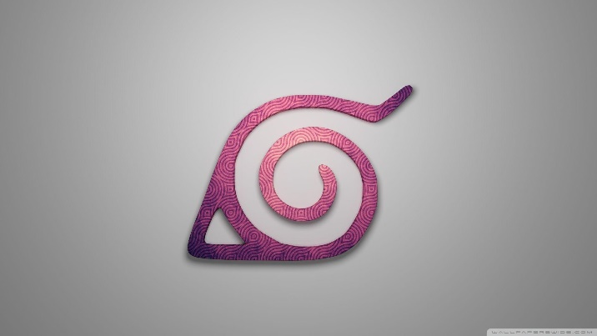 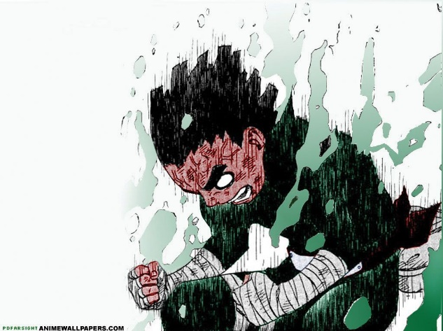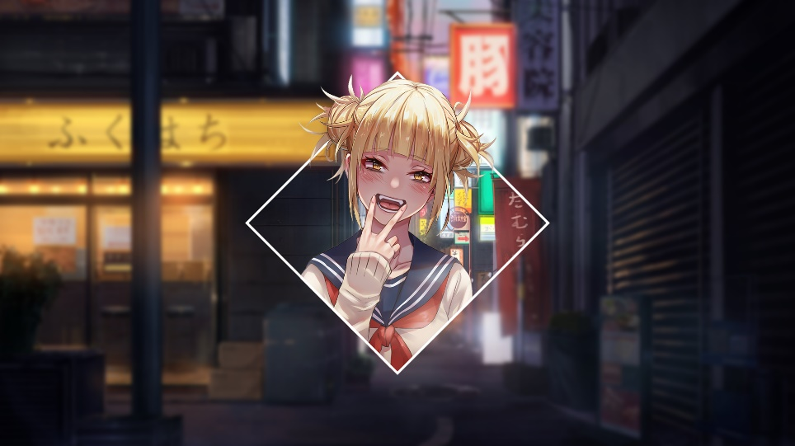

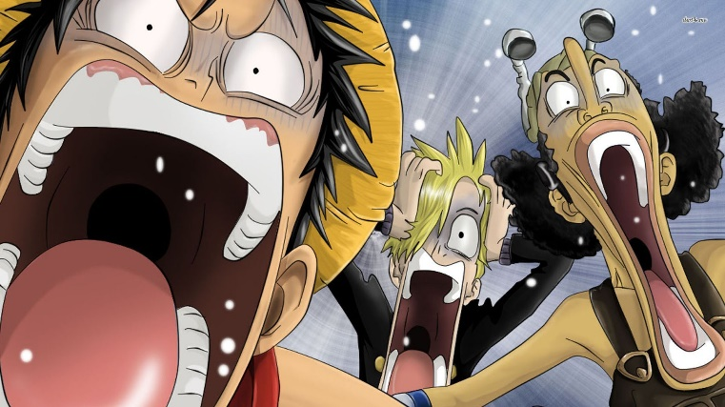

**OUTPUT**

**File 1 - ca1**

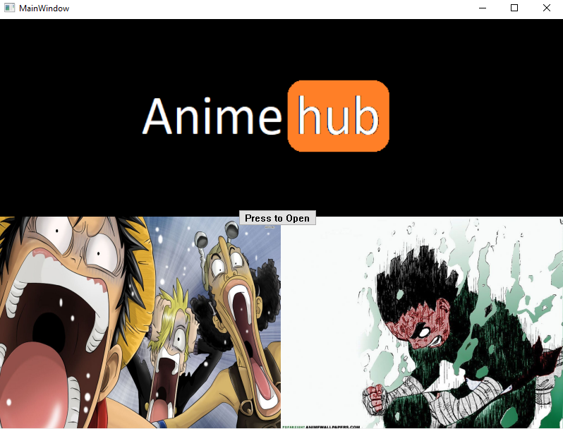

**File 2 – ca2**

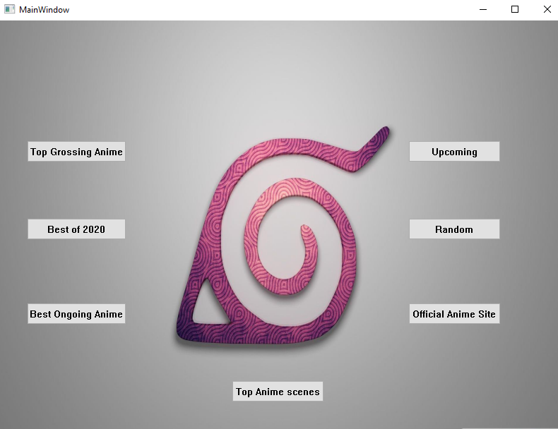

**Files – tgaa, tgaa2, tgaa3, tgaa4 have**

**similar outputs.**

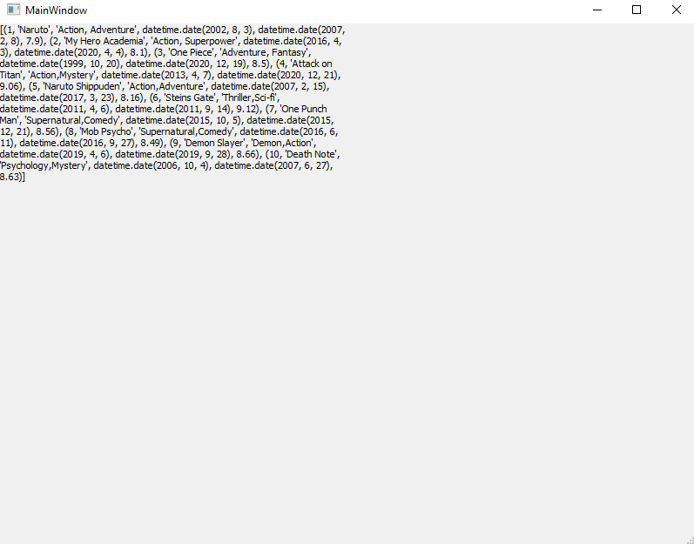

**File – tgaa5 output is myanimelist**

**website**

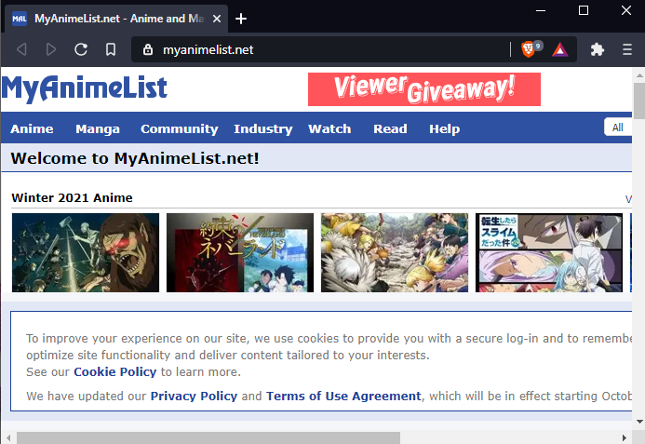

**File – tgaa6**

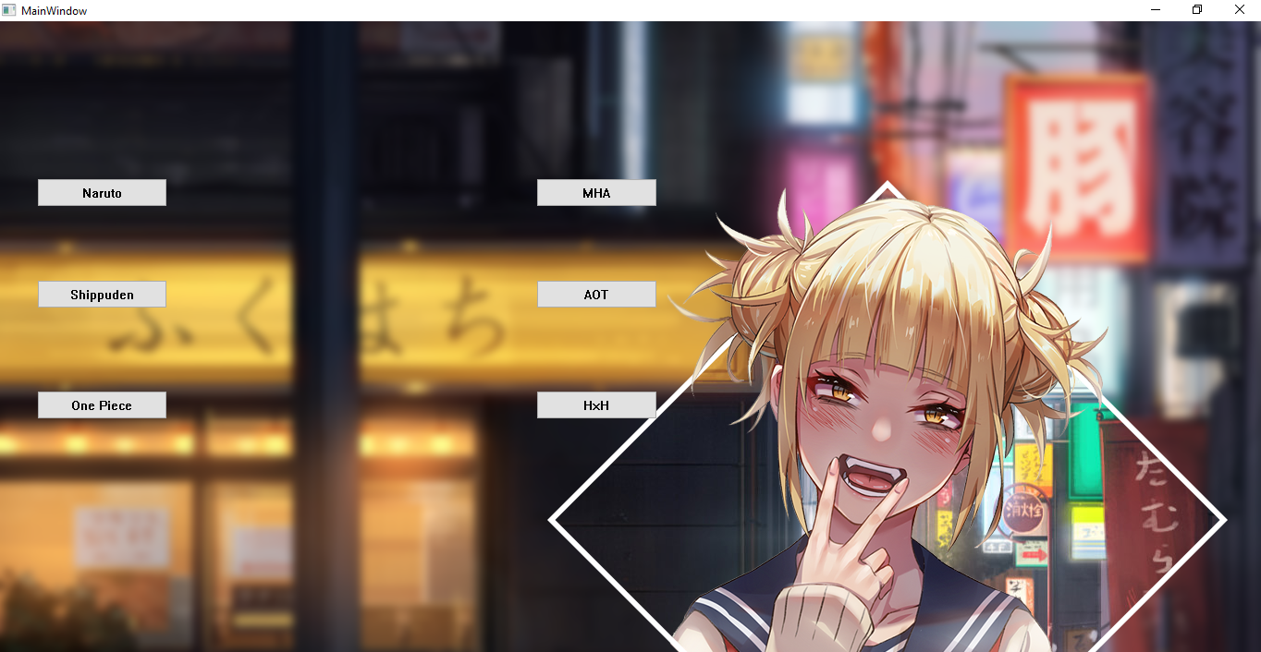

**Output of other buttons in this**

**window are similar to MHA (Below)**

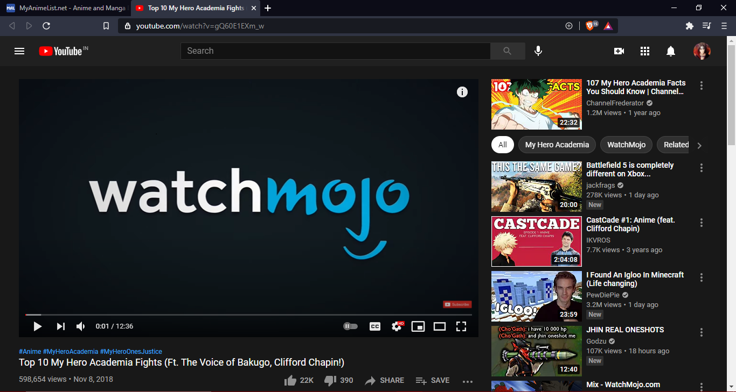

**BIBLIOGRAPHY**

**Images**

[**https://morioh.com/p/11fa65926ab9**](https://morioh.com/p/11fa65926ab9)

[**https://wallpapercave.com/**](https://wallpapercave.com/)

**Information**

[**https://myanimelist.net/**](https://myanimelist.net/)

[**https://en.wikipedia.org/wiki/Wikipedia**](https://en.wikipedia.org/wiki/Wikipedia)